|  |
| --- |
|  |



**4 January 2013** **The Weekly Bulletin of Rotary Club of Kathmandu Mid-Town** **Bc-4.1/012-13**

**District : 3292 Web: www.rotarymidtown.org.np Club Id : 26776**

**JANUARY IS ROTARY AWARENESS MONTH**

Awareness is an important part of the Rotary work that can be divided into two parts.

It is imperative that members are well aware of Rotary’s goals – that Rotary is an organization that works for peace and better understanding between people.

The other part of Rotary awareness is the sharing of information outside of our organization.

Friday, 28 December:

Club Holiday. No meeting.

# Weekly Meetings and Programs :

|  |  |  |
| --- | --- | --- |
| Date | Program/Speaker | Program/Topics of Presentation |
| 4 Jan 2013 | Dr Rabindra Shrestha | Nepal cultural role in the Indian Subcontinent |
| 11 Jan 2013 | HE Asko Luukkainen,  Ambassador of Finland | Nepal-Finland Relations |

Friday, 4 January:

In-house Speaker Rtn Dr Rabindra will be talking on Nepal cultural role in the Indian Sub-continent.

**RI President Sakuji Tanaka's Speech:**

Rotary Club of Kathmandu Mid-Town Charter Nite on 19 Nov 2012

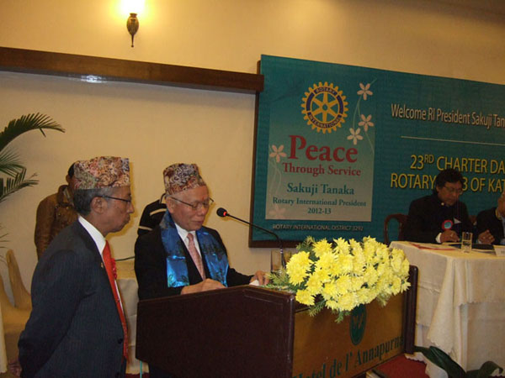

*RI President Sakuji Tanaka addressing the meeting*

Good evening!

It is a wonderful pleasure to be here in Kathmandu, and to join you at the chartering of the Rotary Club of Kathmandu Mid-Town.

Being a Rotarian is an enormous commitment. It takes a great deal of time and effort, and significant resources as well. To do a good job in Rotary, you have to make Rotary a priority. And most of us have many competing priorities in business, in our families, and in our other responsibilities. So why have all of us chosen to make Rotary a part of our lives? What is it about Rotary that pulls us in so strongly? For each of us, the answer is different. But for all of us, Rotary allows us to aim higher in our lives. It allows us the chance *to do more, to be greater*.

Six years ago, at the Centennial Convention in Chicago, I heard past president Glenn Estess speak. He said that what he found as a characteristic common to all Rotarians was simply “*an overwhelming desire to be of assistance*.”

Rotarians are people who are kind and who care about others. We want to be able to give help when it is needed, and Rotary is a way for us to help more, and more effectively than we could ever do alone. Sometimes, it is hard to see the importance of our work. We talk about building world peace. We talk about making the world safer and healthier. But it is not always easy to keep this perspective. Sometimes, we see only the job that is in front of us. We do not see all the good that can come from it. But you can never know how much good can come from one good work.

Some of you know that I grew up in a very poor region of Japan, during a time of great difficulty for the entire country. I wanted very much to have an education. I wanted to travel. It seemed impossible. There was no money. This was also the situation for many of my friends. But one of our teachers decided to help us. He found a glass factory in Tokyo that would hire us, and arranged for us to work there and live in a dormitory. And he arranged as well for us to go to night school.

To me, this was the answer to a dream. I asked my parents for their permission, and they said I should go. So I said goodbye to my father and my mother. I put all of my belongings into a small basket, and I got on the train with my teacher and two of my friends. Our teacher brought us to the factory in Tokyo and showed us where we would live, where we would work, and where we would study. Then he went back to Nigata and to his job in the school there.

That was many years ago. I did not go back to Nigata for many years, and I never saw that teacher again. But I have never forgotten his kindness. Because of him, my life has been completely different. I graduated high school. I became successful in business. Today, I am the president of Rotary International. I do everything I can to help other people find their dream, as my teacher helped me find mine.

The direction of my life was completely changed, because one man decided to help, even though he did not have to, even though he did not know where his actions would lead. Today, I understand how important these acts of kindness can be. They may seem small to us. But they are not.

In Japan, there is an idea of *Shikataganai*. This means, it is out of my hands, and there is nothing I can do.

My teacher could have looked at all of us peasant boys, and said, I will teach them to read and write, but that is all they will ever do. They are too poor to get a high school education. *Shikataganai*, it is not something that I can change. Instead, he responded with a different attitude. He took an attitude of *Watashi Shidai* , it is up to me. He saw that we were not able to find a way out of our situation. So he took the problem as his own. He found a solution. He gave us the help we needed, so that we could help ourselves.

Looking back, I know that it was not easy for him. There was no internet in those days. Long-distance telephone calls were very expensive. He probably wrote many letters to arrange everything in Tokyo. And he paid for his own train ticket, to bring us. He did it only because he cared, and he wanted to help. That kindness, and that help, changed my life completely, and the lives of my friends as well. The years that followed were not easy. I worked very hard at the glass factory, and then I went to study late at night. I was always tired. But I was achieving the goal I had had for so many years, to study, to become educated, to be a success.

And I had found a new attitude in my life one of *Watashi Shidai. Watashi Shidai* means, it is up to me! This is how I feel today. This is what I say to all of you. *Watashi Shidai !* It is up to us.

*Watashi Shidai !* It is up to us to set Rotary goals. It is up to us to achieve them.

*Watashi Shidai !* It is up to us to help other people, so that they can help themselves. This is what we believe in Rotary.

I congratulate all of you who are new Rotarians, and new members of the Rotary Club of Kathmandu Mid-Town.

I wish you many years of happy and productive Rotary service. And I remind you all - *Watashi Shidai !* The future of your Rotary club is up to you.

Thank you.

*Source:  President Devendra Gongal*

**BRRP, "Mission Impossible":**

**Be part of the TEAM, before it's too LATE**

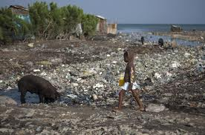 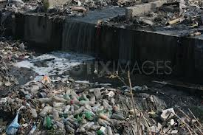

An urgent need has been realized to get all the interested parties in a joint concerted effort to control and contain the irreparable damage to the environment - a previously unimaginable problem associated with them. The River Bagmati and River Bishnumati are glaring examples. A number of NGO's and various organizations have been involved, in one way or other in trying to overcome the problems.

To give a new life to the effort, through an effective TEAM work participation, Common Concern Nepal (CCN) with Rotary International District 3292-Nepal,has taken the lead in coming up with a much needed sustainable awareness campaign covering the River Bishnumati corridor, through an effective coordinated effort of all the genuinely interested parties, to support the KVDA & KMC efforts, in which the Community will be playing an effective role, displaying their sense of ownership and pride on this ambitious Bishnumati river Re-habilitation project (BRRP), code named, "Mission Impossible", starting from its source, at Shivapuri to its confluence with the River Bagmati, a distance of 18 km., at "Teku Doban."

Terms of Reference: The project is visualized to be a 3 year program, which will be broken down into two phases:

a) Phase 1 will be through a PPP (private public participation) program, by dividing the river corridor

into 10 Sectors., with Budhanilkantha area as Sector 1. Following its effectiveness, the same modus

operandi will be followed in the other Sectors;

b) Phase 2 will be a national level project, under German Advisory Team, Prof. Dr. Radermacher of

Germany, working under the concurrence of the main stake holders, KVDA, KMC & the District

Development Committee LDO, with concerned Government Departments involved. This is at

present in its preliminary stage of planning;

c) The Goal of the start up program on 22 Dec. 2012 is to get all the stakeholders of the community of

Budhanilkantha Bridge area (Sector 1), to show their concern about the gravity of the problem by

coming out in force to make this campaign a success. This will be followed by targeting the

community at the next bridge location / School (Sector wise), during every last Saturday of the

month respectively, till the entire River Bishnumati corridor of 10 Sectors has been covered;

d) The participation of the external partners are a show of its support for this noble venture.

*Source:* *PP Pratap Malla*

*In Rotary, our business is not profit. Our business is peace. Our reward is not money, but the*

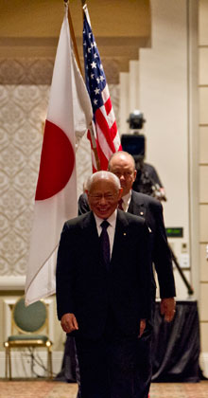

*happiness and satisfaction of seeing a better, more peaceful world — one that we have*

*achieved through our own efforts.*

**RI President Sakuji Tanaka**

**Committee Chairpersons' Column:**

**?????**

**Past Presidents' Column:**

**?????**

On Lighter Side :

Click here ⇩



A Thought For The Day:

**The older I get, the better I used to be !**

Great Quotes:

***The wise man, even when he holds his tongue, says***

***more than the fool when he speaks !!***

Puzzle:

Number 9 Puzzle:

*You multiply any number by 9; add together all individual numbers of the product,*

*integers and decimals, the product will be 9 or multiple of 9's always !*

*Try here:*

Factor Any number Product Sum total of all numbers

(a) (b) (a*b) of the product

9 7 63 6+3=9

9 89 801 8+0+1=9

9 448 4032 4+0+3+2=9

9 1235 11115 1+1+1+1+5=9

9 95837 862533 8+6+2+5+3+3=27 2+7=9

9 637062 5733558 5+7+3+3+5+5+8=36 3+6=9

9 1.63 14.67 1+4+6+7=18 1+8=9

9 29.918 269.262 2+6+9+2+6+2=27 2+7=9

9 0.78892 7.10028 7+1+0+0+2+8=18 1+8=9

And so on and on….

*courtesy:* PP Subarna Joshi

NB: Send any informations/photos that may be of interest to the Club or Rotarians in general to

BC Editor: RR Shrestha at email: rryesrr@gmail.com

## 4 Jan 2013 The Weekly Bulletin of Rotary Club of Kathmandu Mid-Town bc-4.1/012-13